# CS 255 System Design Document Template

## UML Diagrams

### UML Use Case Diagram

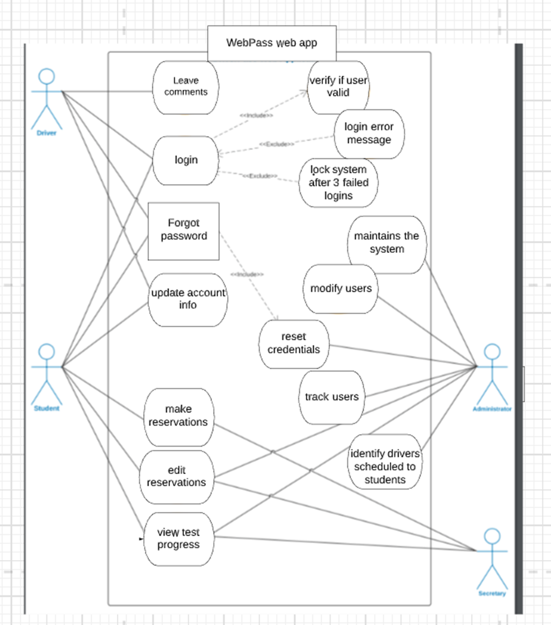

### UML Activity Diagrams

*Student booking appointment:*

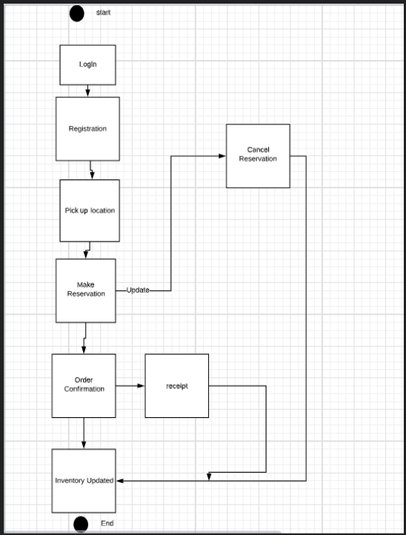

*Admins updating driving packages:*

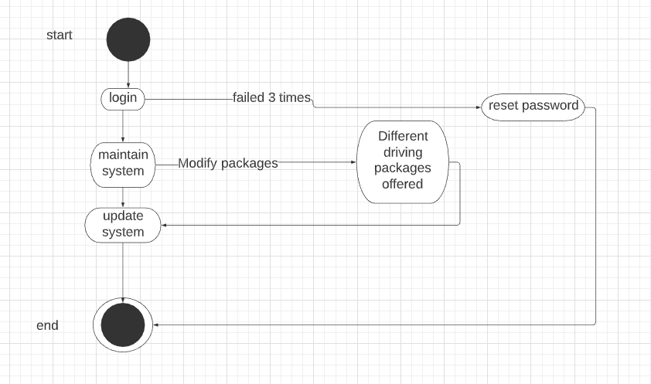

### UML Sequence Diagram

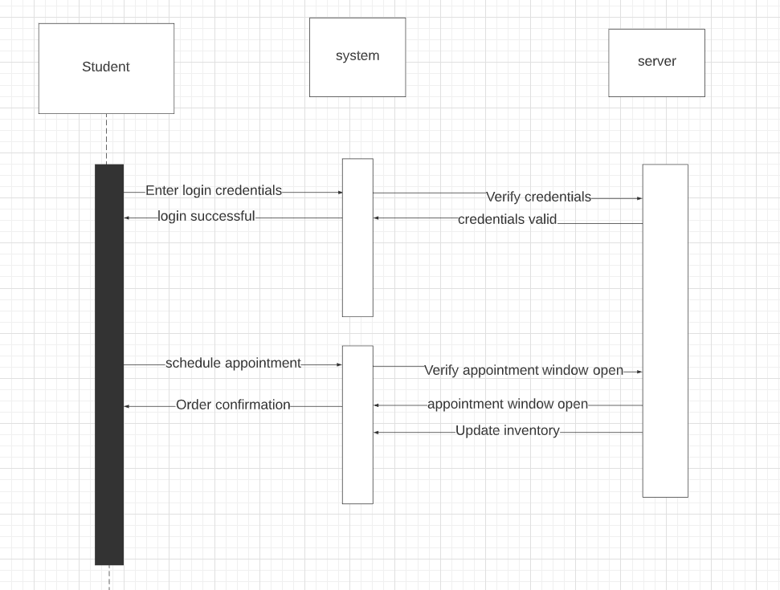

### UML Class Diagram

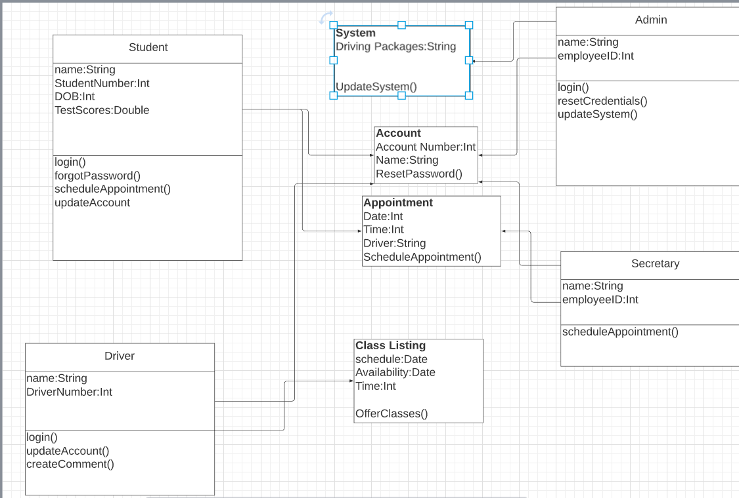

## Technical Requirements

*Technical Requirements are Performance,* *Authorization levels, Security, Administrative functions, Transaction corrections, adjustments, and cancellations. The system needs to perform efficiently by having a response time of 5ms.* *This system will run in a web/cloud environment. The system will run on iOS and Android. The backend will require SQL to support this app. The system will also use SSL since security is an important requirement. The system will only run on up to date browsers. And there will be different authorization levels for the users. Each role in the system will have different privilege, but sometimes those privileges will overlap. For example, all the various users can reset their password. And Finally, Students will be able to update their orders, whether it is cancelling, adding, or deleting.*